

PROJECT REPORT

Pokemon Game
Semester: | Programming Fundamentals
Class: | K25ISTG01 2.0
Group: | Group 3
Instructor | Bui Dang Nha
Team members: | Bui Dang Nha  Bui Dang Nha

Index
Pokemon Game 1
Index 2
I. Project introduction 4
II. Analyze System Requirements 6
1. Use Case 7
1.1 Use Case 7
1.2 Login description 8
1.3 Battle Wild Pokemon description 9
1.4 Catch Pokemon description 10
1.5 Battle GymLeader/Pokemon League description 11
1.6 PvP Battle description 12
2. Activity Diagram 14
2.1 Login 14
2.2 Battle Wild Pokemon 15
2.3 Catch Pokemon 16
2.4 Battle GymLeader/Pokemon League 17
2.5 PvP Battle 18
III. Design Details 19
1. UI Design 19
1.1 Login 19
1.2 Main Menu 19
1.3 Starter Selection 20
1.4 Story Exploration 20
1.5 Battle Screen 21
1.6 Inventory Items 21
1.7 Victory - Level Up - Evolution 22
1.8 Pokemon League Challenge 22
1.9 PvP Battle 23
1.10 PvP Result 23
2. Code Design (Class Diagram) 24
2.1 Application Layer
2.2 Domain Layer
2.3 Infrastructure layer
2.4 Presentation Layer
3. Sequence Diagram 25
3.1 Login 25
3.2 Battle Wild Pokemon 26
3.3 Catch Pokemon 27
3.4 Battle GymLeader/Pokemon League 28
3.5 PvP Battle 29
4. Database Design 31
4.1 Entity Relationship Diagram 31
4.2 Database Design Details 32
IV.Test 36
1. Login test 36
1.1 Login test 1 36
1.2 Login test 2 37
2. Battle Wild Pokemon 38
2.1 Battle Wild Pokemon test 1 38
2.2 Battle Wild Pokemon test 2 39
3. Catch Pokemon 42
3.1 Catch Pokemon test 1 42
3.2 Catch Pokemon test 2 42
4. PvP Battle 43
4.1 PvP Battle test 1 43
4.2 PvP Battle test 2 43
5. Save / Load 44
5.1 Save / Load test 1 44
5.2 Save / Load test 2 44
6. Level Up Pokemon test 49
7. Challenge Gym Leader test 49
7.1 Challenge Gym Leader test 1 49
7.2 Challenge Gym Leader test 2 50
8. Select Starter test 50
8.1 Select Starter test 1 50
9. Register Account test 51
9.1 Register Account test 1 51
V. Task Assign (to each team member) 54
VI. Installation Instructions 55

I. Project introduction
This system will provide some basic features including:
Players can register, log in, choose a starter Pokémon, explore the world, encounter and catch wild Pokémon, battle NPCs and other players, manage their Pokémon team and inventory, and progress through a story mode and Pokémon League challenge and also PvP Battle.

- Proposed System
- Create a program for players to register, login and select starter Pokemon.
- Enable players to explore, battle, catch, train and evolve Pokemon.
- Support both single-player mode and multiplayer PvP battles.
- The scope of the project to be applied
- Designed for players who enjoy turn-based strategy and Pokemon games.
- System Name
- Turn-Based Pokemon Console Game
- Deployment Environment
- Windows, Linux, Mac
- Development Tools
- Visual Studio Code
- .NET SDK
- PlantUML/Draw.io Diagram
- MySQL Workbench 8.0 CE
- Customer Requirements
- User registration and login
- Starter Pokemon Selection
- World exploration and wild encounters
- Battle System (PvE and PvP)
- Catch, train and evolve Pokemon
- Team and inventory manangement
- Story progression and Pokemon league challenge

II. Analyze System Requirements
This is a turn-based Pokémon console game where players can register, log in, and choose a starter Pokémon. Players explore the world, encounter wild Pokémon, battle NPCs and other players (PvP), catch and train Pokémon, level up, evolve, and manage their team and inventory. The game features a story mode, a Pokémon League challenge, and a Hall of Fame. All core mechanics—battling, catching, healing, and progression—are implemented with a focus on clean architecture and modular design.

1. Use Case

1.1 Use Case
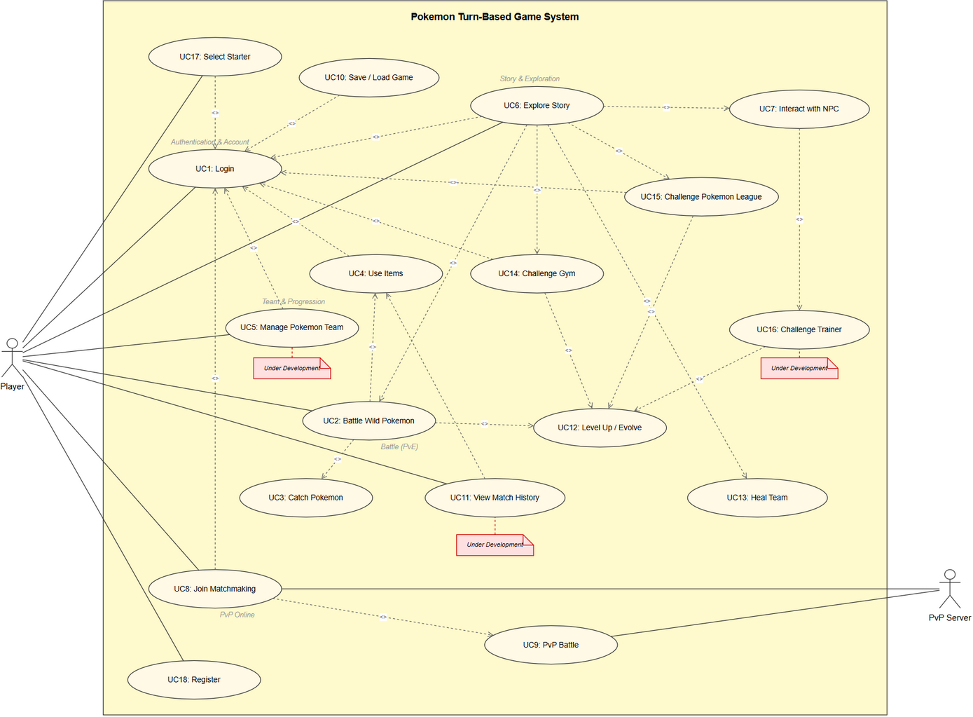

1.2 Login description
Name | Login
ID | UC_001
Description | Player authenticates with existing account to access the game system
Actor | Player
Organizational  Benefits | Secure access control and personalized game experience
Trigger | Player launches application and selects Login from Auth menu
Preconditions | 1. Application is running and displaying Auth menu  2. Player has a registered account in MySQL database
Postconditions | 1. Player is authenticated and redirected to Main Menu  2. Player data loaded into GameSession
Main Course | 1. System displays Auth menu (Login / Register / Exit)  2. Player selects Login  3. System prompts for username  4. Player enters username  5. System prompts for password  6. Player enters password  7. System validates credentials against MySQL database (BCrypt hash)  8. System loads player data into GameSession  9. System displays Main Menu
Alternate Courses | 1. Player selects Register -> extends to UC18  2. Player selects Exit -> application terminates  3. Invalid credentials -> display error, return to step 3
Exceptions | 1. Database connection failure -> display connection error  2. Account locked or disabled -> display account status message

1.3 Battle Wild description
Name | Battle Wild Pokemon
ID | UC_002
Description | Player engages in turn-based combat against a wild Pokemon encountered during exploration
Actor | Player
Organizational  Benefits | Core gameplay loop providing combat experience and Pokemon encounters
Trigger | Player encounters a wild Pokemon during story exploration (UC6)
Preconditions | 1. Player is logged in and exploring the story  2. Player has at least one Pokemon in their team  3. Wild Pokemon spawned by PokemonSpawner
Postconditions | 1. Wild Pokemon defeated, EXP awarded  2. Return to exploration or Pokemon caught
Main Course | 1. System spawns wild Pokemon based on area level  2. System displays battle screen with both Pokemon stats  3. System determines turn order based on Speed stat \n 4. Player selects action (Attack / Catch / Items / Switch / Run)  5. Player selects an attack move  6. System calculates damage (type advantages, STAB)  7. System applies damage to wild Pokemon  8. Wild Pokemon attacks using random move  9. Repeat steps 3-8 until battle ends  10. Wild Pokemon HP reaches 0, player wins  11. System awards EXP and triggers UC12 (Level Up)
Alternate Courses | 1. Player selects Catch -> triggers UC3  2. Player selects Items -> triggers UC4  3. Player selects Switch -> swap active Pokemon  4. Player selects Run -> 50% chance to escape  5. Player Pokemon faints -> force switch to next available  6. Run fails -> wild Pokemon gets free attack turn
Exceptions | 1. All player Pokemon fainted -> battle lost, redirect to healing  2. No available moves -> use Struggle (recoil damage)

1.4 Catch Pokemon description
Name | Catch Pokemon
ID | UC_003
Description | Player attempts to capture a wild Pokemon using a Poke Ball during battle
Actor | Player
Organizational  Benefits | Team building mechanic allowing players to collect and expand their roster
Trigger | Player selects Catch action during a wild Pokemon battle (UC2)
Preconditions | 1. Player is in an active wild Pokemon battle (UC2)  2. Player has at least one Poke Ball in inventory  3. Battle is against a wild Pokemon (not trainer battle)
Postconditions | 1. Wild Pokemon added to player team  2. Poke Ball consumed from inventory  3. Battle ends
Main Course | 1. Player selects Catch action from battle menu  2. System checks Poke Ball availability  3. System calculates catch rate (HP ratio, ball type)  4. System simulates ball shakes (1-3 shakes)  5. System adds Pokemon to player team  6. System removes one Poke Ball from inventory
Alternate Courses | 1. No Poke Balls -> display message, return to battle menu  2. Catch fails -> Pokemon breaks free, battle continues  3. Team full (6 Pokemon) -> Pokemon sent to storage  4. Trainer battle -> catch action disabled
Exceptions | 1. Invalid Pokemon state -> catch attempt rejected  2. Inventory error -> display error, return to battle menu

1.5 Battle GymLeader description
Name | Challenge Gym
ID | UC_004
Description | Player challenges a Gym Leader to earn a badge for League qualification
Actor | Player
Organizational  Benefits | Major progression milestone driving story advancement toward Championship
Trigger | Player reaches a Gym location during story exploration (UC6)
Preconditions | 1. Player is at a Gym location in story  2. Player has at least one Pokemon capable of battling  3. Gym has not been previously defeated
Postconditions | Success: Player earns Gym badge  Fail: Player out of pokemon, then need to heal all at pokemon center.
Main Course | 1. Player enters Gym and interacts with Gym Leader NPC  2. System displays Gym Leader dialogue and challenge prompt  3. Player accepts the Gym challenge  4. System sets up trainer battle (IsTrainerBattle = true)  5. Battle proceeds using UC2 battle mechanics  6. Player defeats all Gym Leader Pokemon  7. System awards Gym badge to player  8. System checks total badge count for League eligibility
Alternate Courses | 1. Player loses battle  2. Badges collected -> UC15 unlocked  3. Gym already defeated -> Gym Leader provides dialogue only
Exceptions | 1. All player Pokemon fainted -> battle lost, heal required  2. Gym Leader data missing -> skip gym, log error

1.6 PvP Battle description

Name | PvP Battle
ID | UC_005
Description | Two players engage in real-time turn-based Pokemon battle over network
Actor | Player, PvP Server
Organizational  Benefits | Competitive multiplayer experience and end-game content
Trigger | Matchmaking (UC8) successfully pairs two players
Preconditions | 1. Both players matched via UC8 (Matchmaking)  2. BattleRoom created on PvP Server  3. Both players connected via SignalR (BattleHub)
Postconditions | 1. Battle result recorded  2. PvP stats updated in MySQL database
Main Course | 1. Server initializes BattleRoom with both players teams  2. System displays opponent active Pokemon and battle UI  3. Both players select their action simultaneously  4. Server determines turn order based on Speed stats  5. Server broadcasts battle state to both clients  6. Server declares winner, updates PvPWins/PvPLosses
Alternate Courses | 1. Player Pokemon faints -> forced switch  2. Player forfeits -> opponent wins by default
Exceptions | 1. Opponent disconnects -> Player wins by default  2. Network timeout -> attempt reconnection, forfeit after timeout  3. Server crash -> battle voided, no stats changed

2. Activity Diagram

2.1 Login
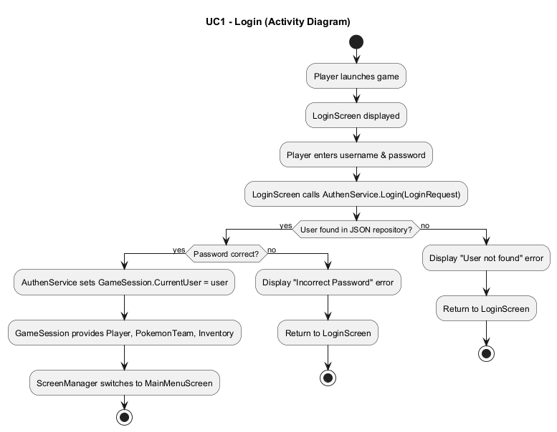

2.2 Battle Wild Pokemon

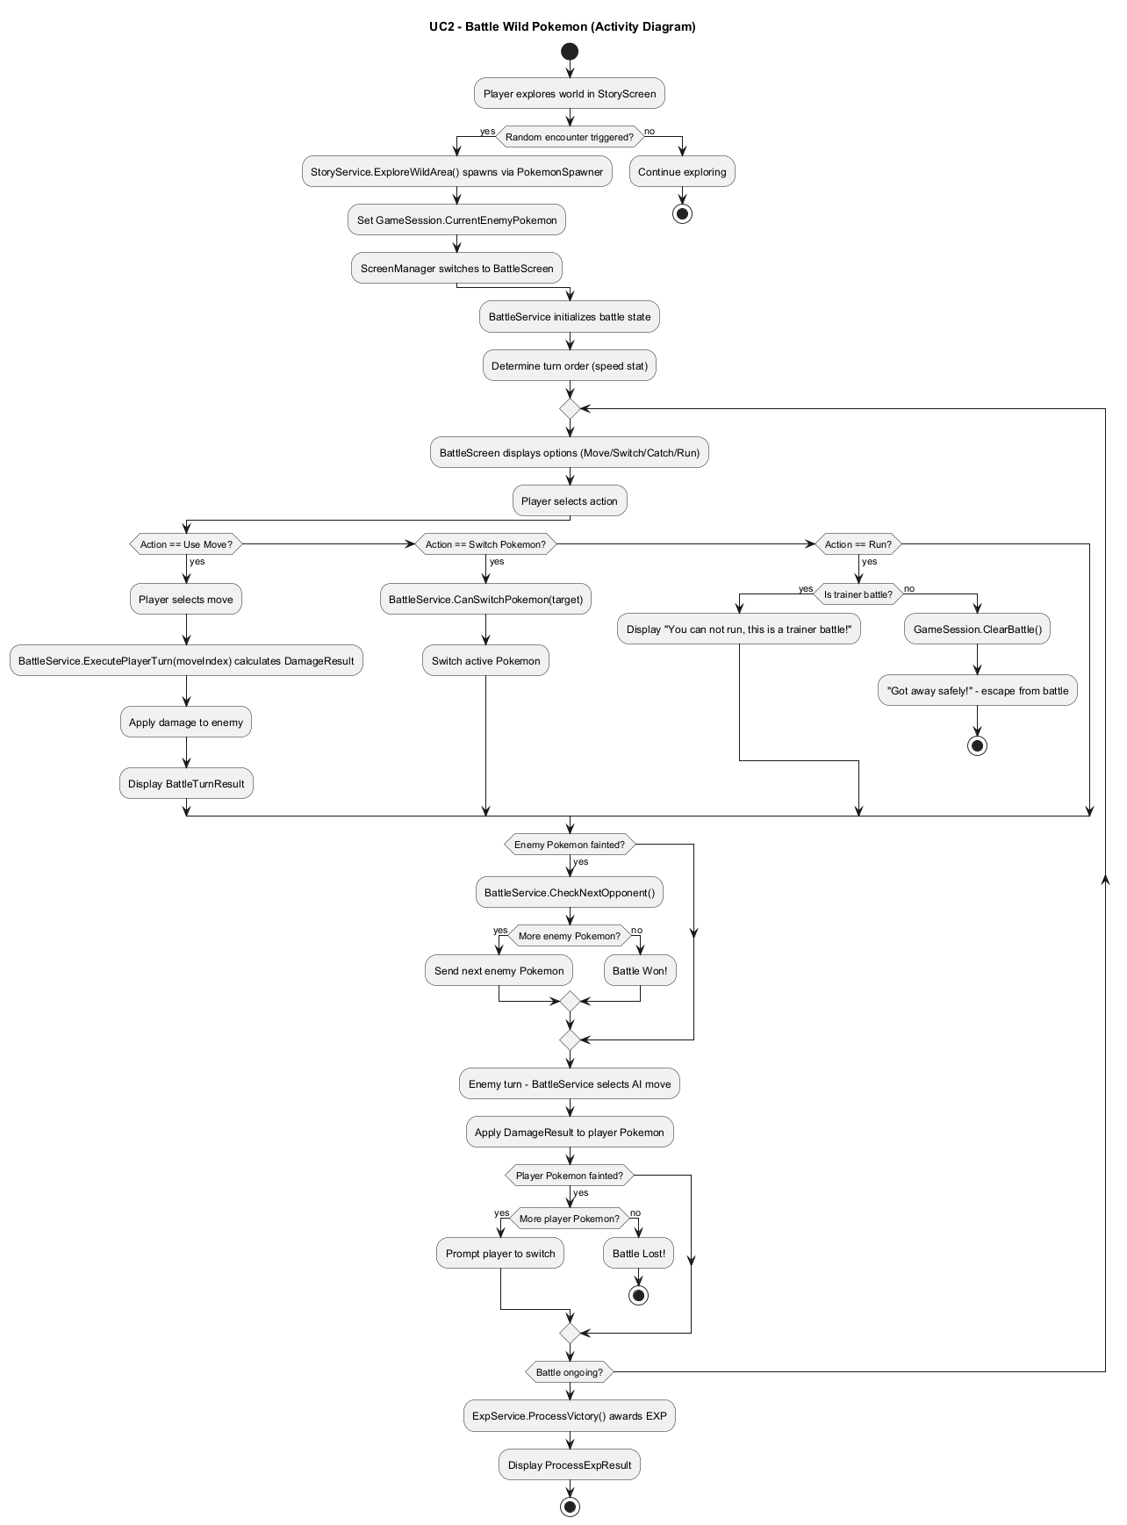

2.3 Catch Pokemon
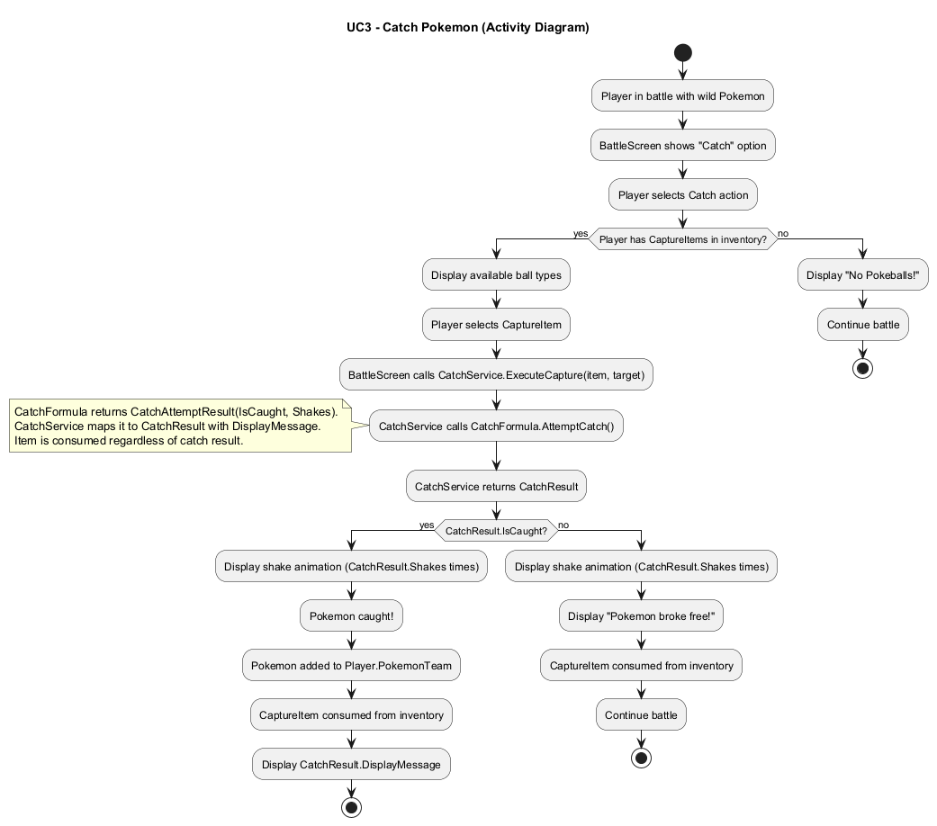

2.4 Battle GymLeader

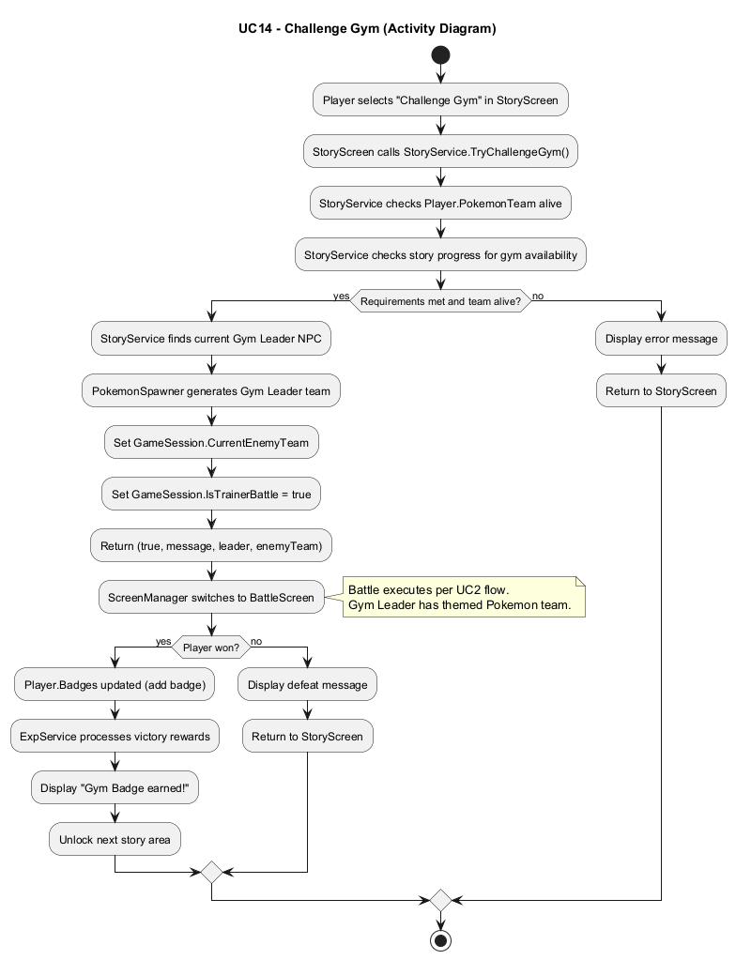

2.5 PvP Battle

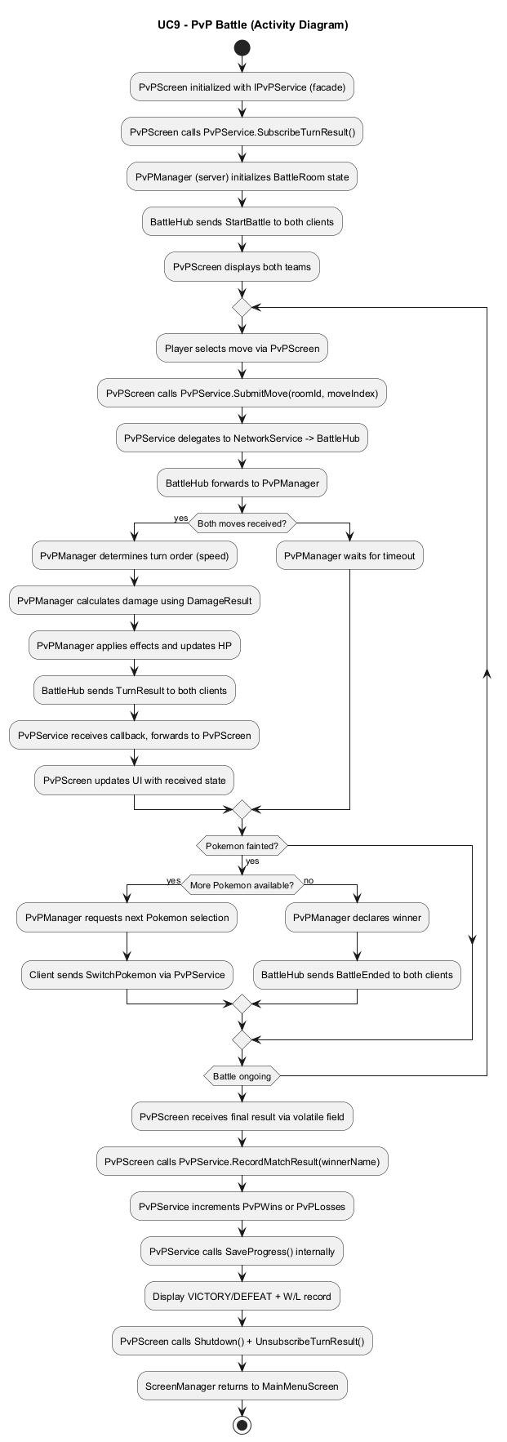

III. Design Details

1. UI Design

1.1 Login
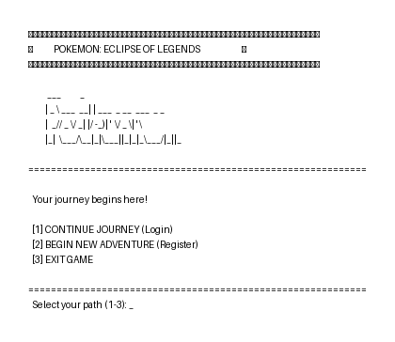

1.2 Main Menu
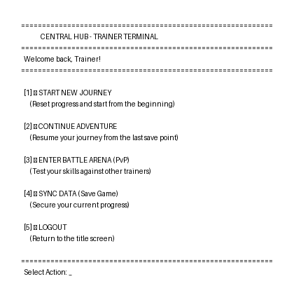

1.3 Starter Selection
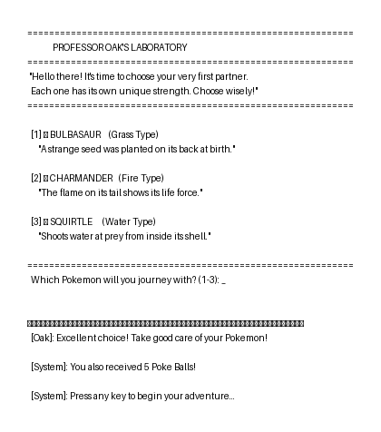

1.4 Story Exploration
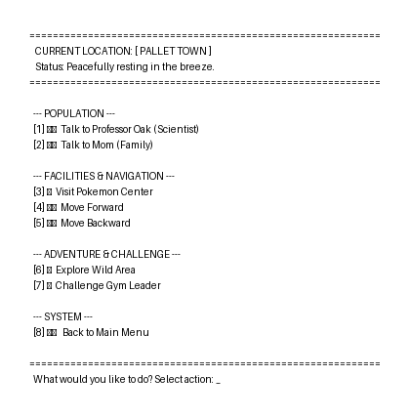

1.5 Battle Screen
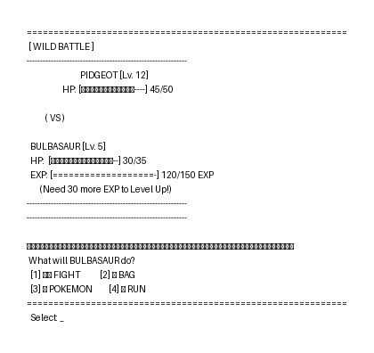

1.6 Inventory Items
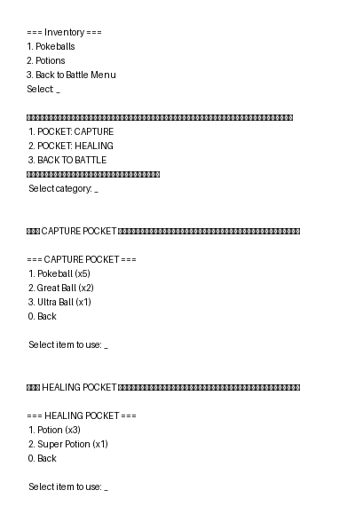

1.7 Victory - Level Up - Evolution
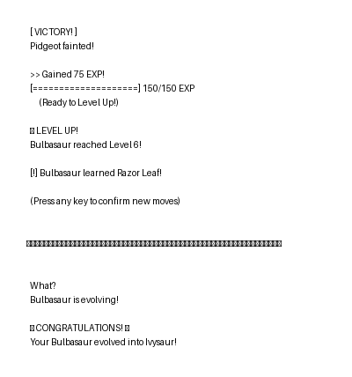

1.8 Pokemon League Challenge
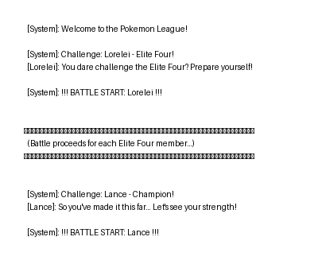

1.9 PvP Battle
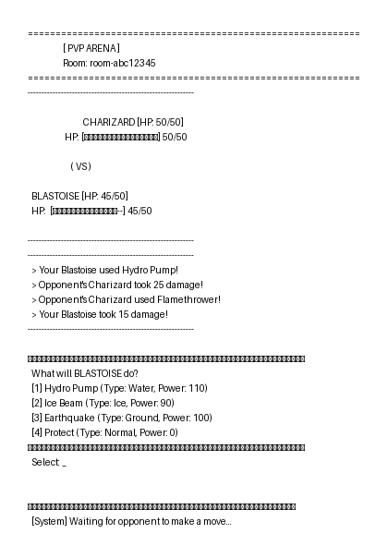

1.10 PvP Result
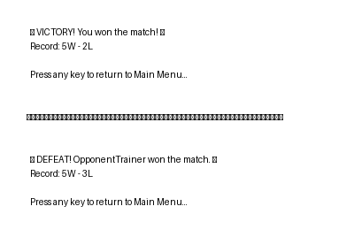

2. Code Design (Class Diagram)

2.1. Application Layer
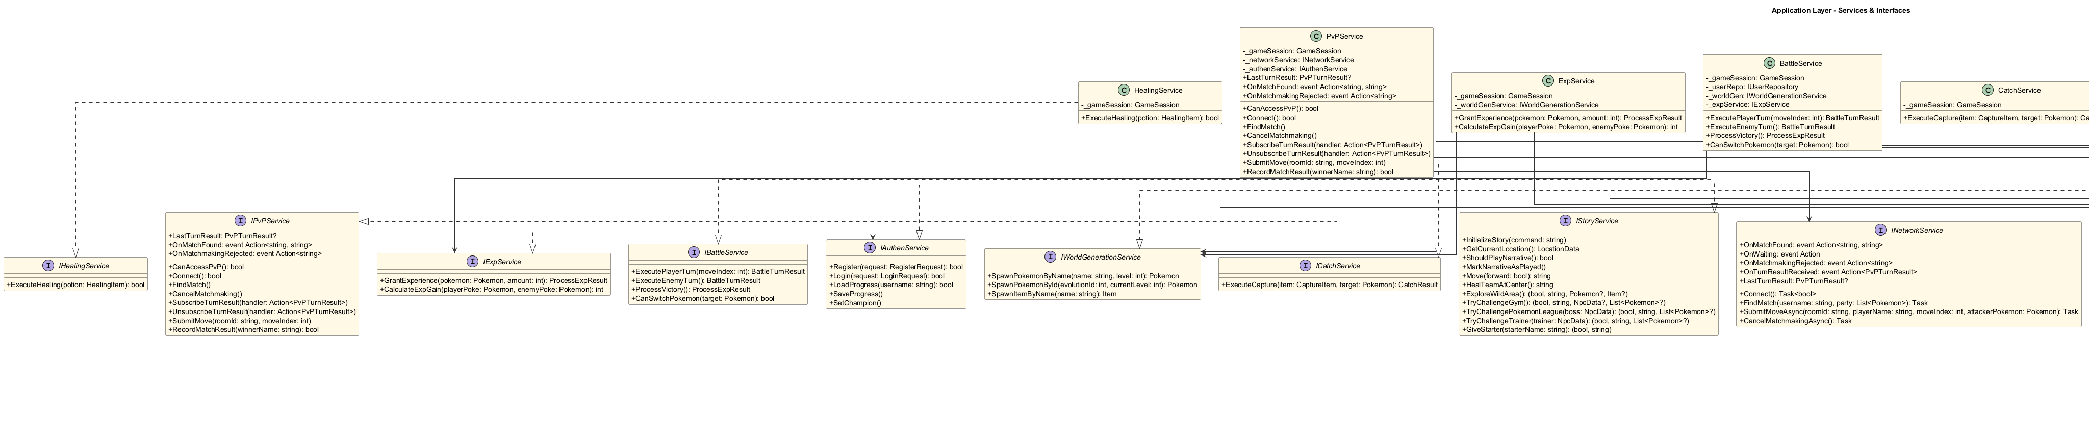

2.2. Domain Layer
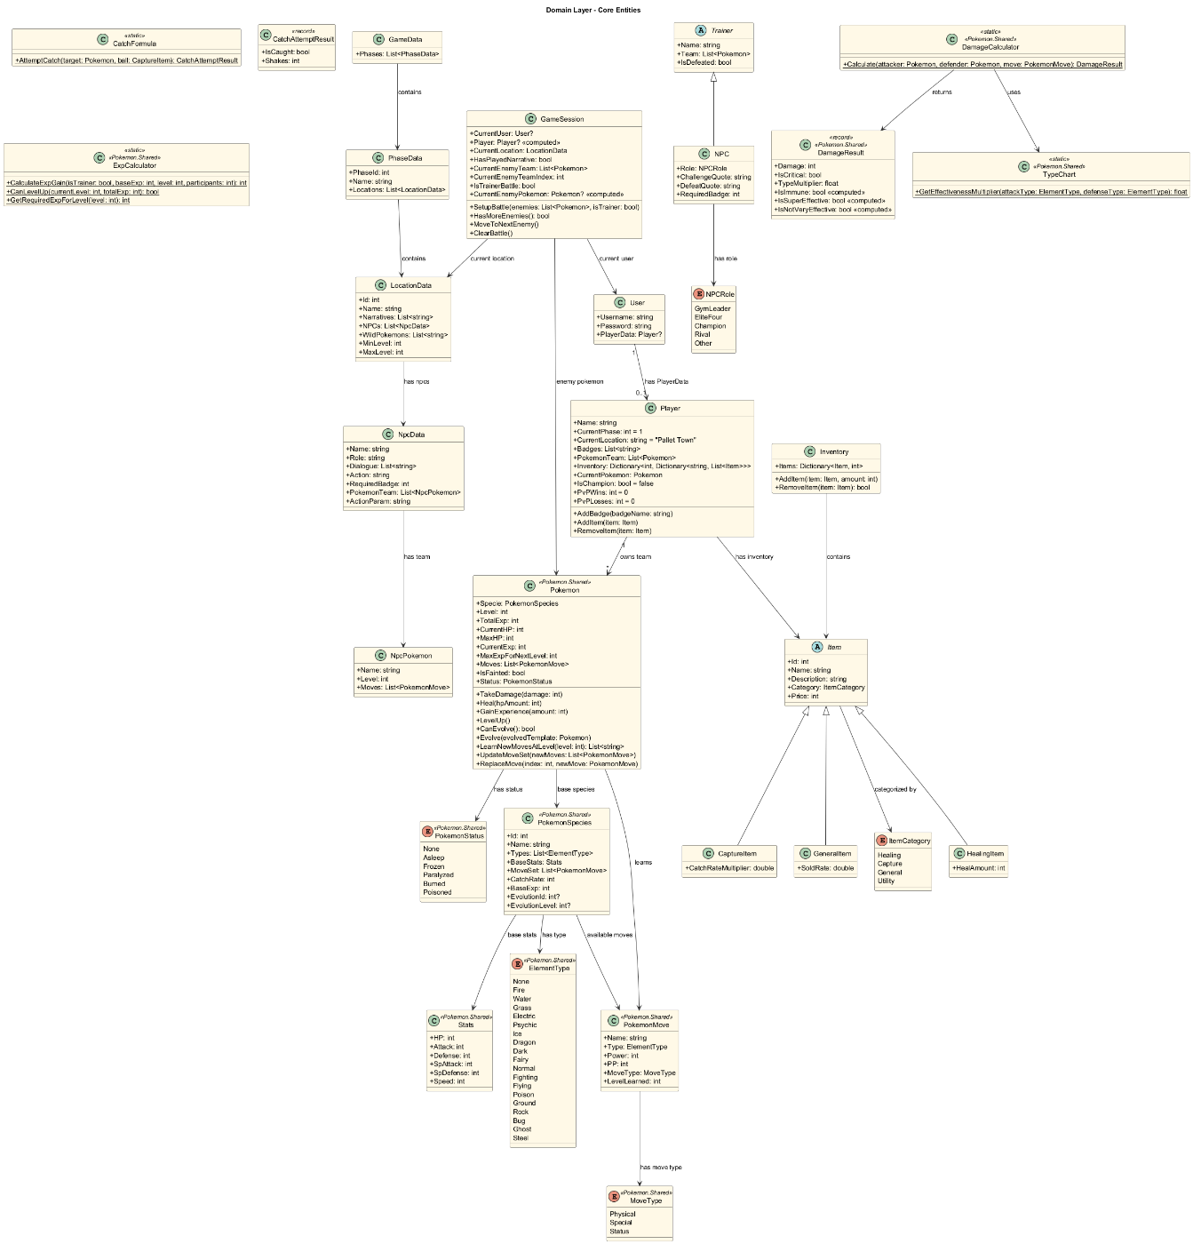

2.3. Infrastructure Layer
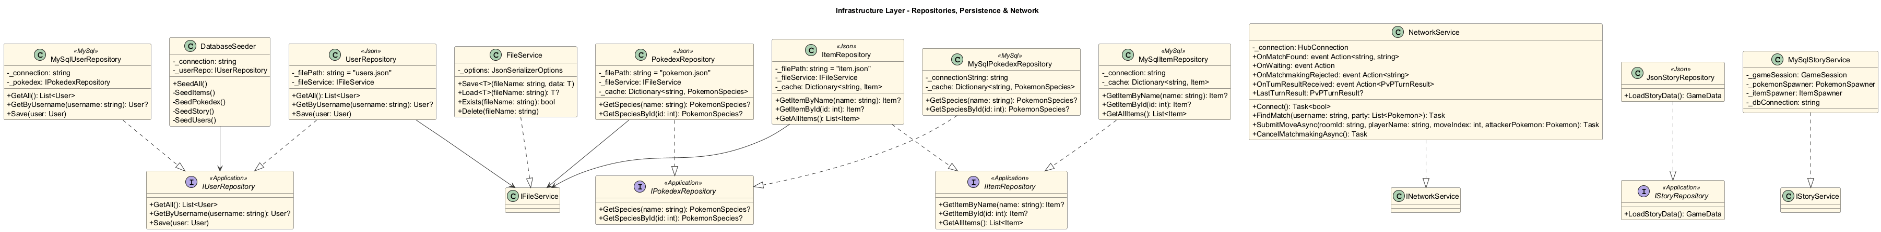

2.4. Presentation Layer
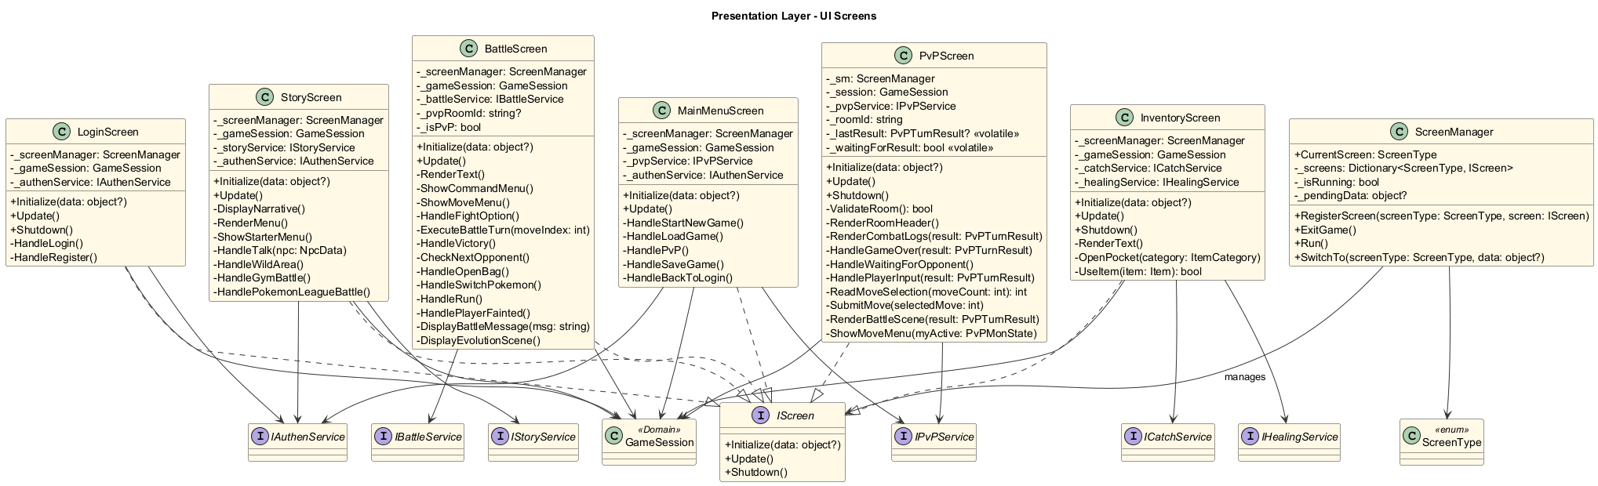

3. Sequence Diagram

3.1 Login
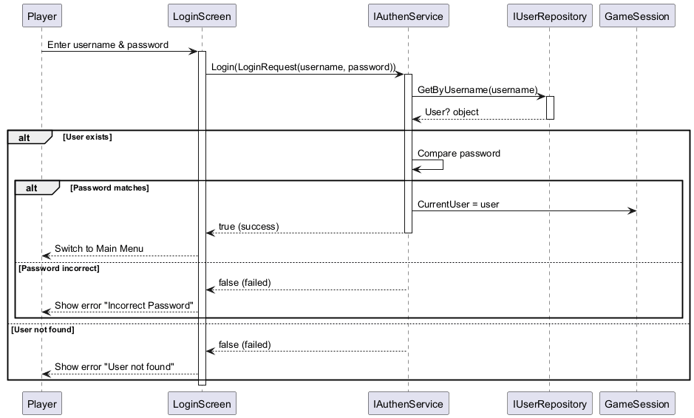

3.2 Battle Wild Pokemon

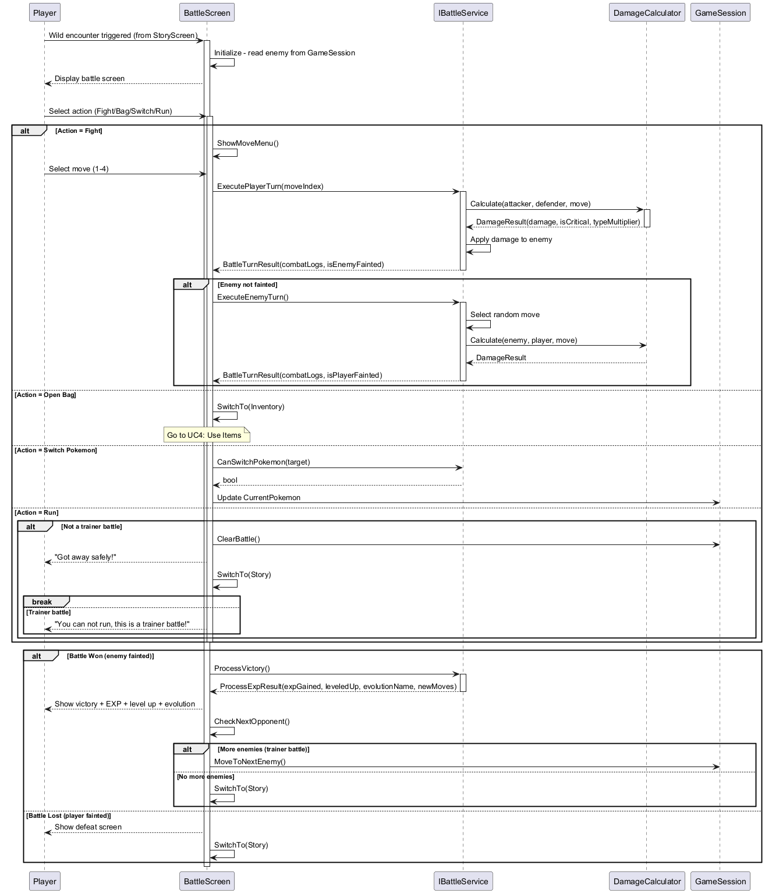

3.3 Catch Pokemon

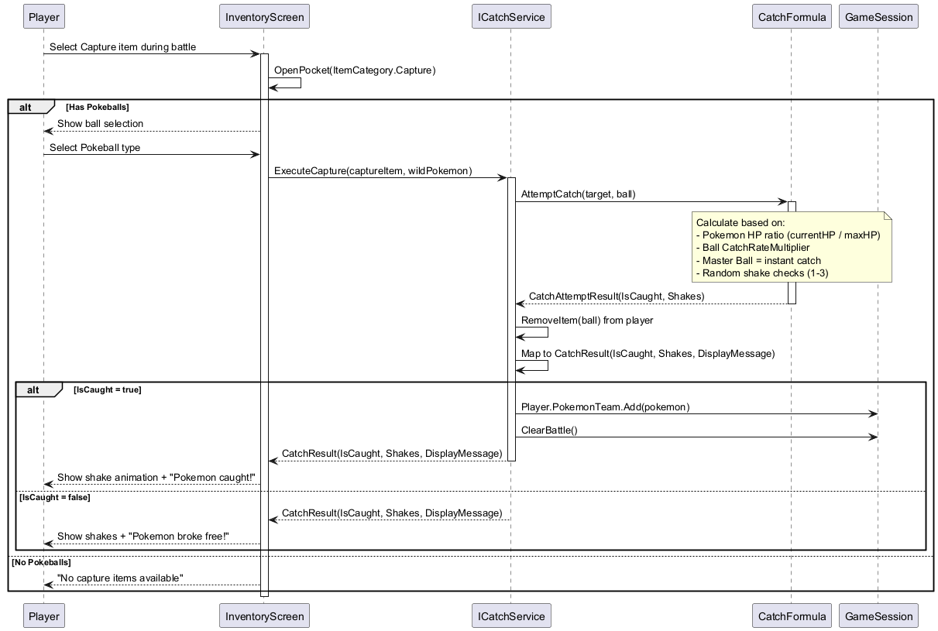

3.4 Battle GymLeader
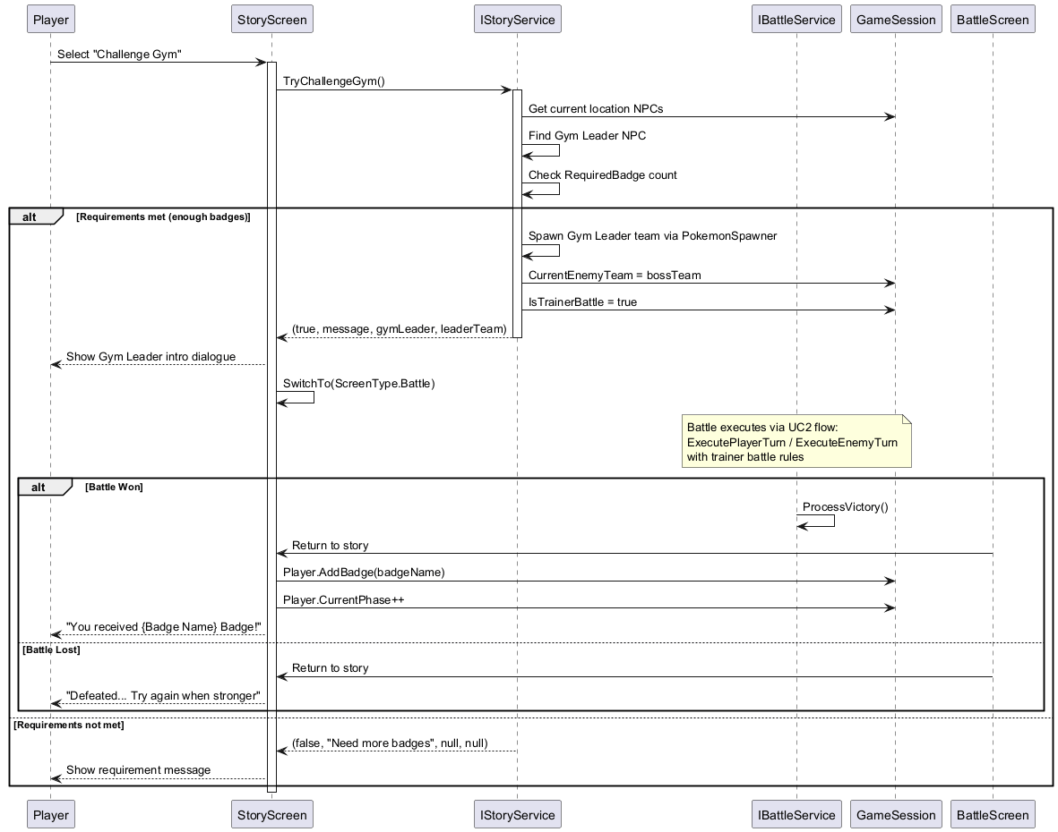

3.5 PvP Battle 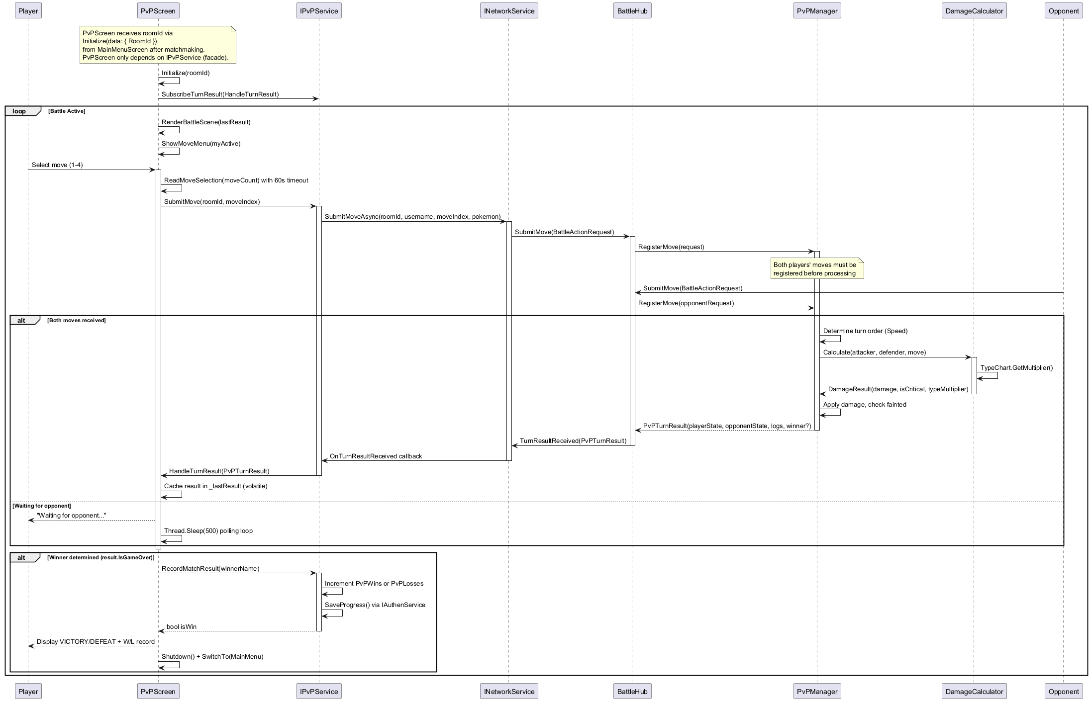

4. Database Design

4.1 Entity Relationship Diagram

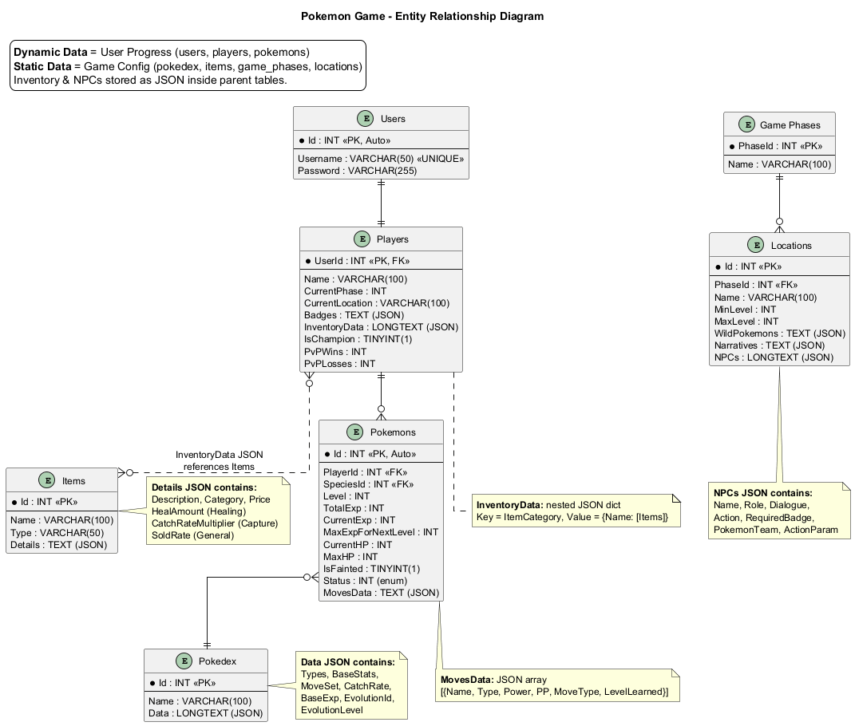

4.2 Database Design Details
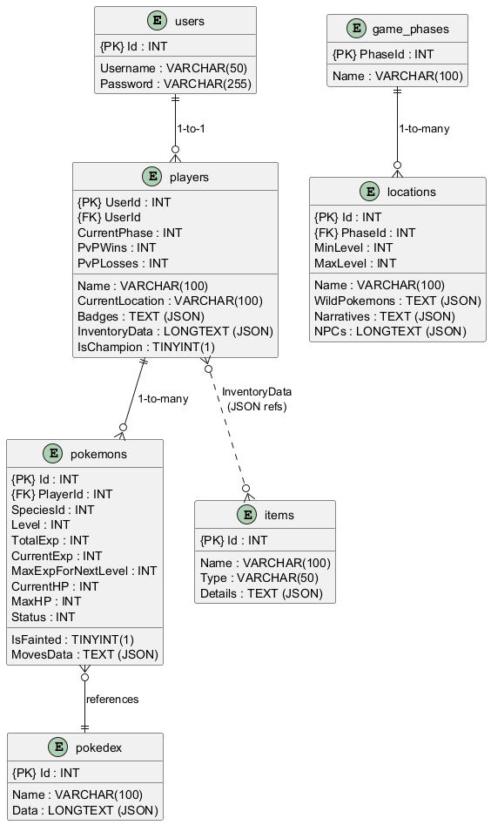

users
Column Name | Data Type | Constraints | Description
Id | INT | PRIMARY KEY, AUTO INCREMENT | Unique identifier for the account
Username | varchar(50) | UNIQUE, NOT NULL | Player's login username
Password | varchar(255) | NOT NULL | Hashed password

players
Column Name | Data Type | Constraints | Description
UserId | INT | PRIMARY KEY, FOREIGN KEY | 1-to-1 link with users.Id
Name | VARCHAR(100) |  | Player's in-game display name
CurrentPhase | INT | DEFAULT 1 | Current story phase
CurrentLocation | VARCHAR(100) |  | Player's current location name
Badges | TEXT |  | JSON array storing collected badge names
InventoryData | LONGTEXT |  | JSON string containing the player's inventory data
IsChampion | TINYINT(1) | DEFAULT 0 | 0: Not champion, 1: Defeated the Pokemon League
PvPWins | INT | DEFAULT 0 | Total number of PvP match wins
PvPLosses | INT | DEFAULT 0 | Total number of PvP match losses

pokemons
Column Name | Data Type | Constraints | Description
Id | INT | PRIMARY KEY, AUTO_INCREMENT | Unique identifier for each individual Pokemon
PlayerId | int | NOT NULL, FOREIGN KEY | Link to players.UserId (The owner)
manufactory_name | INT | NOT NULL, UNIQUE | Manufacturer name
SpeciesId | INT | NOT NULL | Logical link to pokedex.Id (Pokemon species)
Level | INT | NOT NULL | Current level
TotalExp | INT | DEFAULT 0 | Total accumulated experience points
CurrentExp | INT | DEFAULT 0 | Current experience at the current level
MaxExpForNextLevel | INT | DEFAULT 0 | Experience required to reach the next level
CurrentHP | INT | NOT NULL | Current Hit Points (Health)
MaxHP | INT | NOT NULL | Maximum Hit Points
IsFainted | TINYINT(1) | DEFAULT 0 | 0: Alive, 1: Fainted
Status | INT | DEFAULT 0 | Enum for status conditions (e.g., 0 = None, 1 = Asleep, etc.)
MovesData | TEXT |  | JSON array of currently learned moves and their PPs

items
Column Name | Data Type | Constraints | Description
Id | INT | PRIMARY KEY | Item's unique identifier
Name | VARCHAR(100) | NOT NULL | Item name
Type | VARCHAR(50) | NOT NULL | Item category (e.g., 'Healing', 'Capture')
Details | TEXT |  | JSON data containing item effects and stats

pokedex
Column Name | Data Type | Constraints | Description
Id | INT | PRIMARY KEY | Pokedex number / Species ID
Name | VARCHAR(100) | NOT NULL | Pokemon species name
Data | LONGTEXT | NOT NULL | JSON data containing BaseStats and default Moveset

game_phases
Column Name | Data Type | Constraints | Description
PhaseId | INT | PRIMARY KEY | Phase unique identifier
Name | VARCHAR(100) | NOT NULL | Name or description of the story phase

locations
Column Name | Data Type | Constraints | Description
Id | INT | PRIMARY KEY | Location unique identifier
PhaseId | INT | NOT NULL, FOREIGN KEY | Link to game_phases.PhaseId
Name | VARCHAR(100) | NOT NULL | Location name
MinLevel | INT | DEFAULT 1 | Minimum level of wild Pokemon appearing current location
MaxLevel | INT | DEFAULT 1 | Maximum level of wild Pokemon appearing at current location
WildPokemons | TEXT |  | JSON array of wild Pokemon species available
Narratives | TEXT | NOT NULL | JSON array containing system narrative dialogues
NPCs | LONGTEXT |  | JSON array containing NPCs and their Pokemon teams

IV.Test

1. Login test

1.1 Login test 1
Test Case Number | 001
Test Case Name | Successful Login with valid credentials
Test Case Description | Verify that a registered player can log in with correct username and password
Preconditions | 1. Application is running  2. Player account exists in MySQL database
Test Case Input | Username: "nhonbonchel"  Password: "kasumi "
Test Case Expected Output | 1. System authenticates successfully  2. Player data loaded into GameSession  3. Main Menu displayed
Test Case Steps | 1. Launch application  2. Select Login from Auth menu  3. Enter username " nhonbonchel "  4. Enter password " kasumi"  6. Verify Main Menu is displayed
Default Value Preverving | Player data matches stored record in MySQL database

1.2 Login test 2
Test Case Number | 002
Test Case Name | Failed Login with empty username or password
Test Case Description | Verify that login fails immediately when player submits empty username or password (just presses Enter)
Preconditions | 1. Application is running
Test Case Input | Username: "" (empty)  Password: "" (empty)
Test Case Expected Output | 1. System displays error "Username/Password cannot be empty"  2. Player returns to Auth menu  3. No authentication attempt made
Test Case Steps | 1. Launch application  2. Select Login from Auth menu  3. Press Enter without typing username  4. System displays empty input error  5. Verify player is returned to Auth menu
Default Value Preverving | No changes to MySQL database or player data

2. Battle Wild Pokemon test

2.1 Battle Wild Pokemon test 1
Test Case Number | 001
Test Case Name | Successful wild Pokemon battle victory
Test Case Description | Verify player can defeat a wild Pokemon and receive EXP
Preconditions | 1. Player is logged in and exploring story  2. Player has at least one Pokemon with HP > 0
Test Case Input | 1. Login with use: nhonbonchel, pass: kasumi  2. Select Continue Adventure – 2 – MainMenu  3. Select Explore Wild Are – 5 – StoryMenu  Player Pokemon: Charmander (Lv.5, HP 42)  Wild Pokemon: Pidgey (Lv.5, HP 45) (Or any pokemon with lower HP)  4. Select Action: Fight (Scratch – Move’s Name)
Test Case Expected Output | 1. Wild Pokemon HP reaches 0  2. Battle ends with victory  3. EXP awarded to Charmander  4. Return to story exploration
Test Case Steps | 1. Encounter wild pokemon during exploration  2. Battle screen displays both Pokemon stats  3. Select Attack action  4. Select Ember move  5. System calculates damage with type advantage  6. Wild Pokemon faints  7. Verify EXP awarded  8. Verify return to exploration
Default Value Preverving | Player Pokemon stats updated with EXP gain

2.2 Battle Wild Pokemon test 2
Test Case Number | 002
Test Case Name | Battle loss when all player Pokemon faint
Test Case Description | Search for products in the system
Preconditions | Same As Test Case 001
Test Case Input | 1. Login with use: nhonbonchel, pass: kasumi  2. Select Continue Adventure – 2 – MainMenu  3. Select Explore Wild Are – 5 – StoryMenu  Player Pokemon: Charmander (Lv.5, HP 42)  Wild Pokemon: Pidgey (Lv.5, HP 45) (Or any pokemon with higher HP)  4. Select Action: Fight (Scratch – Move’s Name)
Test Case Expected Output | 1. Player Pokemon HP reaches 0  2. No more Pokemon available  3. Battle lost message displayed  4. Redirect to healing
Test Case Steps | 1. Encounter wild pokemon during exploration  2. Battle screen displays both Pokemon stats  3. Select Attack action  4. Select Ember move  5. System calculates damage with type advantage  6. Player Pokemon faints  7. System checks for remaining Pokemon  8. No Pokemon available  9. Verify battle lost message  10. Verify redirect to healing option  11. Verify return to exploration
Default Value Preverving | Player Pokemon remain fainted until healed

3. Catch Pokemon test

3.1 Catch Pokemon test 1
Test Case Number | 001
Test Case Name | Successfully catch a wild Pokemon
Test Case Description | Verify player can catch a wild Pokemon with a Poke Ball
Preconditions | 1. Player is in a wild Pokemon battle (UC2)  2. Player has at least 1 Poke Ball  (Can continuously enter wild area to random pickup a item (Can be a pokeball)).  3. Wild Pokemon HP is low
Test Case Input | Wild Pokemon: Rattata (Lv.3, HP 2/31)  Item: Poke Ball (qty: 5 or higher than 0)
Test Case Expected Output | 1. Catch rate calculation succeeds  2. Ball shakes 3 times  3. Rattata added to player team  4. Poke Ball count reduced by 1  5. Battle ends
Test Case Steps | 1. Select Catch action from battle menu  2. System verifies Poke Ball in inventory  3. System calculates catch rate (low HP = high chance)  4. Ball shakes 3 times, all pass  5. Verify Rattata added to team  6. Verify Poke Ball count is 4  7. Verify battle ends
Default Value Preverving | Player team size increased by 1, inventory updated

3.2 Catch Pokemon test 2
Test Case Number | 002
Test Case Name | Catch attempt with no Poke Balls
Test Case Description | Verify catch is blocked when player has no Poke Balls
Preconditions | 1. Player is in a wild Pokemon battle (UC2)  2. Player has at least 1 Poke Ball  (Can continuously enter wild area to random pickup a item (Can be a pokeball)).  3. Wild Pokemon HP is low
Test Case Input | Wild Pokemon: Pidgey (Lv.5) (Any pokemon)  Item: Poke Ball (qty: 0)
Test Case Expected Output | 1. System displays "No Poke Balls available" message  2. Player returns to battle screen  3. No items consumed
Test Case Steps | 1. Select Catch action from battle menu  2. System verifies Poke Ball in inventory  3. System calculates catch rate (low HP = high chance)  4. No Capture item  5. Verify error message displayed  6. Verify return to battle screen  7. Verify inventory unchanged
Default Value Preverving | No changes to inventory or team

4. PvP Battle test

4.1 PvP Battle test 1
Test Case Number | 001
Test Case Name | Successfully win a PvP battle
Test Case Description | Verify player can win PvP battle and stats are updated correctly
Preconditions | 1. Both players matched via UC8  2. BattleRoom created  3. Both connected via SignalR
Test Case Input | 1. Login as user – 1 window console  Username: nhonbonchel  Pass: kasumi  Login as user – 1 window console  Username: kasumi  Pass: nhonbonchel  Run Pokemon Server – 1 window console  2. Select move for each Pokemon on each Window Console
Test Case Expected Output | 1. Battle proceeds with turn-based mechanics  2. Opponent Pokemon defeated  3. Player 1 wins  4. PvPWins incremented in GameSession  5. Player 2 loose  6. PvPLosses incremented in GameSession  7. Recors auto save to My Sql Database.
Test Case Steps | 1. BattleRoom initializes with both teams  2. Both players select actions  3. Server determines turn order by Speed  4. Attacks executed sequentially  6. Verify winner declared  7. Verify PvPWins updated in GameSession  8. Player returns to Main Menu
Default Value Preverving | Winner PvPWins +1, Loser PvPLosses +1 in GameSession (saved to MySQL only when player selects Save Data from Main Menu)

4.2 PvP Battle test 2
Test Case Number | 002
Test Case Name | Win by default when opponent disconnects
Test Case Description | Search for customer in the system
Preconditions | 1. PvP battle is in progress  2. Both players connected
Test Case Input | Opponent connection: disconnected  (Ctrl + C at 1 player’s window console)
Test Case Expected Output | 1. System detects opponent disconnect  2. Player wins by default  3. PvPWins incremented in GameSession  4. Return to Main Menu
Test Case Steps | 1. Battle in progress at turn  2. Opponent connection drops  3. Server detects disconnection  4. Verify player declared winner by default  5. Verify PvPWins updated in GameSession
Default Value Preverving | Winner PvPWins +1, disconnected player PvPLosses +1 (saved to MySQL only when player selects Save Data from Main Menu)

5. Save / Load test

5.1 Save / Load test 1
Test Case Number | 001
Test Case Name | Successfully save game progress
Test Case Description | Verify player can save game state to MySQL database
Preconditions | 1. Player is logged in  2. MySQL database connection is available
Test Case Input | 1. Login with user: nhonbonchel, pass: kasumi  2. Catch Pokemon, or find new items or play pvp.  3. Return to Main Menu – Select Save progress.
Test Case Expected Output | 1. GameSession data serialized  2. Data written to MySQL  3. Save success message displayed
Test Case Steps | 1. Select Save option from menu  2. Verify save confirmation displayed  3. Login again anh check whether data is saved or not
Default Value Preverving | Player data in MySQL matches current GameSession

5.2 Save / Load 2

6. Level Up Pokemon test
Test Case Number | 001
Test Case Name | Pokemon levels up and stats increase
Test Case Description | Verify Pokemon levels up correctly when EXP threshold is met
Preconditions | 1. Player won a battle  2. Pokemon EXP is near level threshold
Test Case Input | 1.Battle Pokemon as TC 4
Test Case Expected Output | 1. Pokemon reaches Level higher Current Level  2. All stats recalculated (HP, Atk, Def, Spd)  3. Level up notification displayed
Test Case Steps | 1. Battle victory awards 30 EXP  2. System adds EXP  3. Pokemon levels up to Lv.10  4. Verify stats recalculated  5. Verify notification displayed
Default Value Preverving | Pokemon level and stats updated in GameSession

7. Challenge Gym Leader test

7. Challenge Gym Leader test 1
Test Case Number | 001
Test Case Name | Successfully defeat Gym Leader
Test Case Description | Verify player can defeat Gym Leader and earn a badge
Preconditions | 1. Player is at a Gym location  2. Gym not previously defeated  3. Player has capable Pokemon
Test Case Input | 1.Select option to challenge gym leader.  2. Battle with current high level pokmon  Ex: Gym Leader: Brock (Rock type) \n Player Pokemon: Squirtle (Lv.15, Water type)
Test Case Expected Output | 1. Trainer battle initiated  2. Player defeats Gym Leader  3. Badge awarded  4. Badge count incremented
Test Case Steps | 1. Enter Gym and interact with Brock  2. Battle starts  3. Defeat all Gym Leader Pokemon  4. Verify badge awarded  5. Verify badge count updated
Default Value Preverving | Player badge count +1, Gym marked as defeated

7.2 Challenge Gym Leader test 2
Test Case Number | 002
Test Case Name | GetOrderByIdTest2()
Test Case Description | Lose battle against Gym Leader
Preconditions | 1. Player is at a Gym location  2. Gym not previously defeated  3. Player has weaker type Pokemon compared to gym leader’s pokemon  Ex: Gym Leader: Brock (Rock type) \n Player Pokemon: Chamender (Lv.15, Fire type)
Test Case Input | 1. Enter Gym and interact with Brock  2. Battle starts  3. All player’s pokemon fainted  5. Verify defeated.
Test Case Expected Output | 1. All player Pokemon fainted  2. Battle lost message displayed  3. No badge awarded  4. Option to retry available
Test Case Steps | 1. Accept Gym challenge  2. Battle proceeds  3. All player Pokemon faint  4. Verify battle lost message
Default Value Preverving | No badge changes, Gym still available

8. Select Starter test

8.1 Select Starter test 1
Test Case Number | 001
Test Case Name | Successfully select a starter Pokemon
Test Case Description | Verify first-time player can select a starter Pokemon
Preconditions | 1. Player just registered and logged in  2. Player has no Pokemon (empty team)
Test Case Input | Player: "newplayer"  Select Start New Game.  Selection: Charmander (Fire type)  (Or any gen 1 pokemon)
Test Case Expected Output | 1. Three starters displayed (Fire, Water, Grass)  2. Charmander selected and confirmed  3. Charmander added to player team
Test Case Steps | 1. System detects first-time player  2. Starter selection screen displayed  3. Review three starter options  4. Select Charmander  5. Confirm selection  6. Verify Charmander in team
Default Value Preverving | Player team has 1 Pokemon, saved to MySQL

9. Register Account test

9.1 Register Account test 1
Test Case Number | 001
Test Case Name | Successfully register new account
Test Case Description | Verify new player can create an account with valid credentials
Preconditions | 1. Application is running at Login menu  2. Select Register  3. Enter username and password
Test Case Input | Username: "pokemon"  Password: "SecureP@ss1"
Test Case Expected Output | 1. Username validated as unique  2. Password hashed with BCrypt  Account created in MySQL database
Test Case Steps | 1. Select Register from Login menu  2. Enter username "pokemon"  3. System validates uniqueness  4. Enter password "SecureP@ss1"  5. System hashes password and stores in MySQL  5. System hashes password and stores in MySQL
Default Value Preverving | New user record created in MySQL database

V. TaskAssign (to each team member)
Group 6 | Laptop Store
No | Task name | Description | Start Date | End Date | Member | Self assessment
1 | Write report |  | 10 April | 11 April | Nha
2 | Code |  | 15 March | 6 April | Nha
5 | Control |  | March | April | Nha

VI. Installation Instructions
- Deployment Diagram
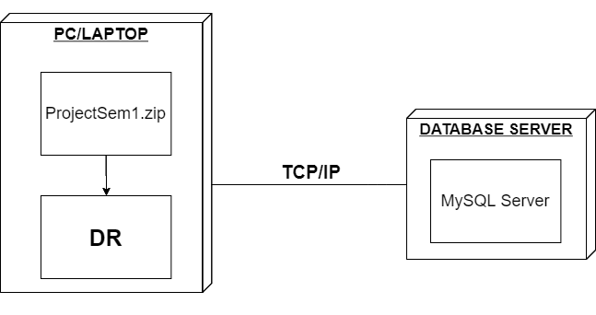
- Installation steps
  - Database Install
  - Server install
  - Application install

